Famous Faces - Match these faces to the names

Christina-Aguilera George-Clooney
Eminem Halle-Berry
Bruce-Willis Jean-Claude-Van-Damme
Demi-Moore Jennifer-Lopez
Angelina-Jolie Keanu-Reeves
Drew-Barrymore Leonardo-Di-Caprio

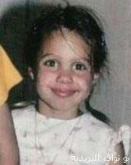 |  | 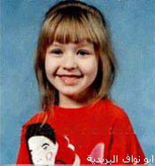
1 | 2 | 3
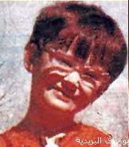 | 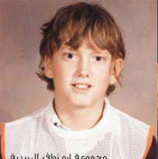 | 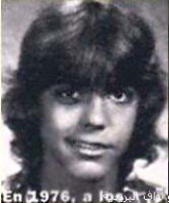
4 | 5 | 6

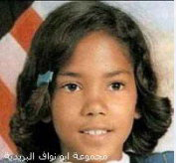 | 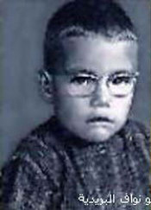 | 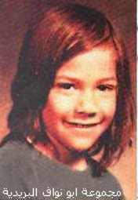
7 | 8 | 9
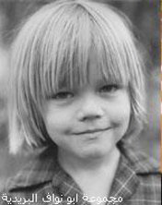 | 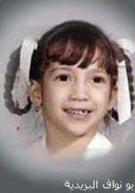 | 
10 | 11 | 12

Christina-Aguilera George-Clooney
Eminem Halle-Berry
Bruce-Willis Jean-Claude-Van-Damme
Demi-Moore Jennifer-Lopez
Angelina-Jolie Keanu-Reeves
Drew-Barrymore Leonardo-Di-Caprio

